Virtual Bounty

**List of Topics:**

Movies

Sports

TV Series

Fantasy - comics anime etc

Minimalism

Gaming

Lit - books

Gen

Music

Conspiracy theories

Quora questions

Tech-related

Use this as a template for questions

**Question Example_Number:** Nishaanth

**Topic:** Gen

Connect the images.  
  
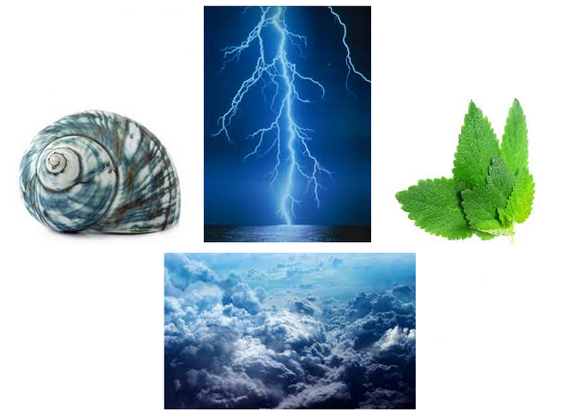

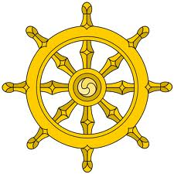

**Clues** **(can be vague right now):**   
Elementary, Self-Similarity  
  
**Answer:**

Buddhabrot

**Reason:**

The first image is supposed to point you to fractals.  
The second image is to point you to buddhism.

Connect the two as buddha fractal and you obtain the buddhabrot.

____________________________________________________

Question Number : 1

Question Maker : Chinmay

Difficulty : ***Easy***

Clues : Not required

Topic : Tech(Recent)

Question : How do we identify you?

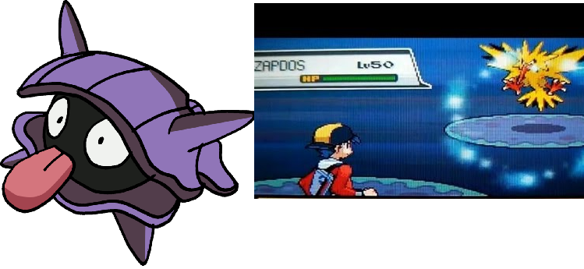

Answer : cve-2014-6271

Reason : Shellder points to Shell. Zapdos to shock. The connection is pretty simple.

pradeep: cve 6271.let that be the answer.

kbhat: or cve-2014-6271

chinmay : accepted

____________________________________________________

Question Number : 2

Question Maker : Chinmay

Question Difficulty : ***Moderate***

Topic : Gen/Music

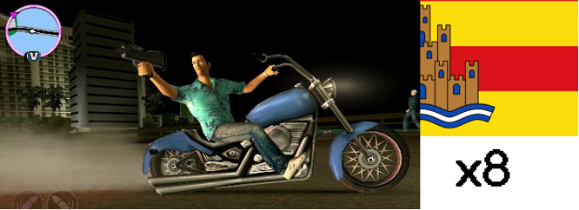

Answer : Swedish House Mafia

Reason :  The first image is that of GTA Vice City(mobile) which is heavily based on the city of   Miami. The second image is ⅛ th of the flag of Ibiza. Googling the second image does not give us anything. Miami 2 Ibiza was a famous song by the Swedish House Mafia .

Clues : “ I hate break-ups” -> Since SHM dissolved the partnership recently.

Resolved Clue : t = 2π √l/g

____________________________________________________

Question Number : 3

Question Maker : Chinmay

Difficulty : ***Moderate***

Topic : TV Series/ Gaming

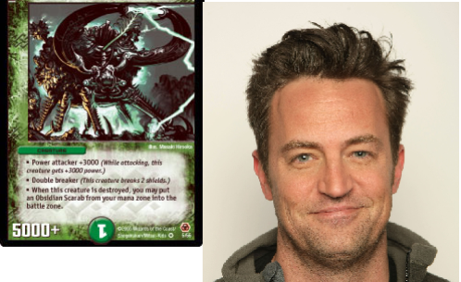

Answer : Benny

Reason : The first image is that of a creature from an old trading card game Duel Masters. It is the image of the creature named “ Obsidian Scarab “ . The catch here is Obsidian . Second is Matthew Perry. Obsidian and Matthew Perry on googling together give away Fallout : New Vegas in the first page of google results. The connect is that Matthew voiced the character Benny in the game.

Clues: Depends on the spam. None required.

ptv:awesome question

kartik: good stuff man

i don't know if this makes the answer too simple.but the clue for this could be

"google? "

this points to bing. Points to Chandler bing. points to Perry.

the clue almost gives it away so we should hide it well. in the background or something

or better the question mark is in the colors of the google logo

____________________________________________________

Question Number : 4

Question Maker : KSB

Difficulty : ***Moderate***

Topic : TV Series

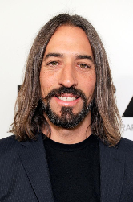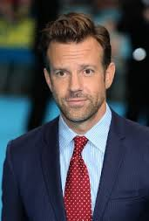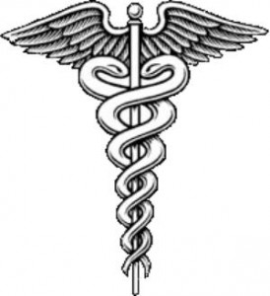

My Friends and I rented an apartment nearby. What’s your plan?

Answer: James Wilson

Reason - The two dudes are the husbands/partners of Lisa Cuddy and Thirteen. This, plus the caduceus leads people towards House.

The next line is just to get people to think about roommates rather than just House. Wilson was House’s roommate sometime.

ptv: put a picture of a caduceus. makes it a little harder

____________________________________________________

Question Number : 5

Question Maker : Chinmay

Difficulty : ***Tough***

Topic : Tech/Music

Question :

www.youtube.com/sPjwXBQTXvm=v?hctaw

Answer : Brian Eno

Reason : Catch 1 : The string after youtube.com is reversed. After reversing the string , we get a youtube Video. The tune is the classic Windows 95 startup tune. The image is the cover picture of the album “Another day on Earth” by Brian Eno. Eno was also famous for composing the Win95 theme when Windows officials asked him to design a song which was emotional, inspirational, etc in under 7 sec.

(Currently I have hosted the Video on my ‘pseudo’ channel. But if we have one or more of YTube related questions we can maybe host it on VB channel )

Clue: YOU MUST TRY ‘WATCH’ing THIS VIDEO

Question Number : 6

Question Maker : KSB

Difficulty : ***Moderate***

Topic : Gen

Question :

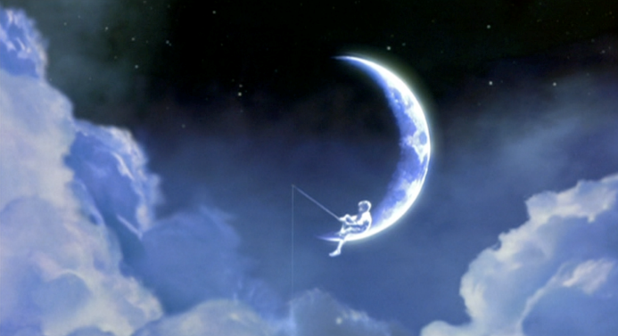

https://www.linked.in.com/pub/mars-traci/32/438/6b5

Answer : ISRO

Reason : Nothing to do with dreamworks. :P Take ‘moon’ from the logo, ‘mars’ from ‘Mars Traci’. Suggests something to do with space (to me). The ‘7’ is just cuz we’re going on and on about ‘Rs. 7/km’ :P

So, you have Mangalyaan and Chandrayaan -> ISRO.

Clue:

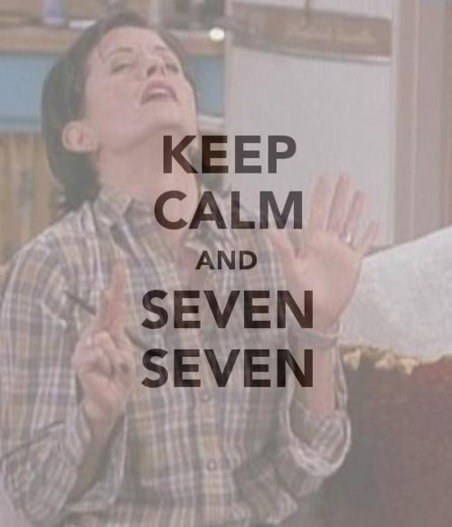

ptv:another clue could be mom. ( mars orbital mission)

you could put a picture of a tv show of the same name.

Question Number : 7

Question Maker : KSB

Difficulty : ***Easy***

Topic : Sports



Answer : QPR

Reason : Kangana Ranaut points to Queen(movie) and the person is a cartoon named Steve from the show Park Ranger. So, Queens Park Rangers.

Clue : White City

Question Number : 8

Question Maker : Chinmay

Question Level : ***Final***.

Difficulty : Insanely Messed up :P

Topic : Movie/Book/Sport

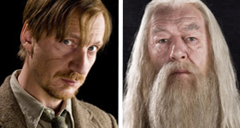

Answer : Dhyanchand

Reason : Remus Lupin is the anagram for Primus Lune which means the Full moon in Latin. We take Moon from there. Dumbledore also acted as Gandalf who was a Wizard. Take Wizard. Moon in Hindi is Chand. Chand and Wizard we get Major Dhyan Chand who was an acclaimed Hockey player also known as the Wizard of Hockey/India. The clue is the Bharat Ratna. He was recently in the news for not getting the Bharat Ratna over Sachin Tendulkar.

Clue :

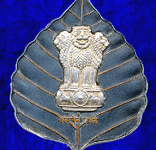

Question Number : 9

Question Maker : Chinmay

Difficulty : ***Moderate***

Topic : Music/TV/Comic

Question: a/an/the?

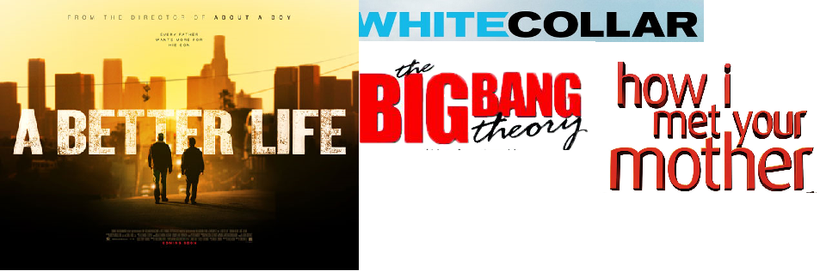

Answer : Pink Kryptonite

Reason : A better life is the name of the movie. Added a question on articles. Once they google   “the better life” they will immediately stumble upon 3 Doors Down. The most famous of their songs is Kryptonite. Combine that with the fact that all the TV series leads are gay we get Pink Kryptonite which is supposed to turn Superman gay on enough exposure. The clue is the Batman Belt . In the Justice League comics, time and again it is shown that Batman always carries a piece of Kryptonite with him to stop Superman if he turns bad.

Clue :

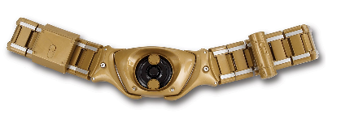

Alternate Clue : AMD K5

ptv alternate clue: amd k5

Question Number : 10

Question Maker : Chinmay

Difficulty : ***Tough***

Topic : TV / Trivia

Question :

Jeff Bezos defeated me when the last century was about to close. It was a **shock**, but I **tackled** it well.

Answer: Pikachu

Reason: Pikachu was voted No.2 for the Person of the Year in 1999. Though he was defeated by Amazon.com director Jeff P. Bezos it became very popular then. If we google 1999 and Jeff Bezos we immediately get Time magazine. A bit of hunting will give us Pikachu. The words ‘shock’ and ‘tackle’ in the question is to confirm the doubt. Since even on using the Yellow Stone Pikachu does not evolve, the clue is about Phoebe and Ross’ argument over evolution.

Clue :

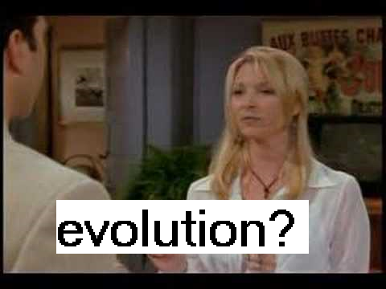

Question Number : 11

Question Maker : Chinmay

Difficulty : ***Moderate***

Topic : TV/History

Question :

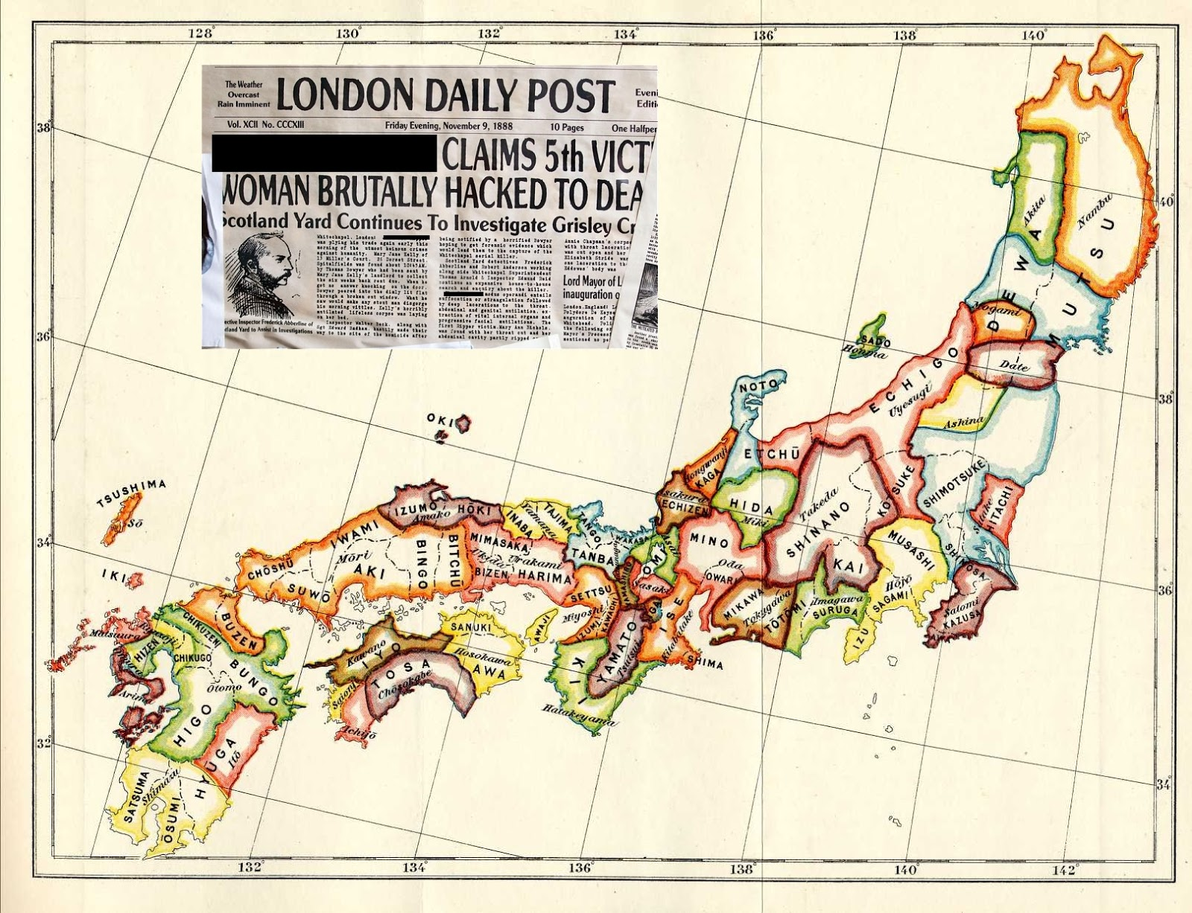

Answer : Samurai Jack

Reason : The first image is the newspaper article for Jack the Ripper. We can just google the name of the police officer in the image to get Jack the Ripper. The second image is of Feudal Japan. Both of them together give Samurai Jack. Jack is always trying to use a time portal to go back in the past and save the world from destruction. But as shown in the TV series , he never succeeds.

Clue : The try and try and you will never succeed.

Sugar spice and everything nice

**Question 12:** Kartik Sreenivasan (Ten10)

Difficulty: ***Easy***

**Topic:** Gen

Connect the images.

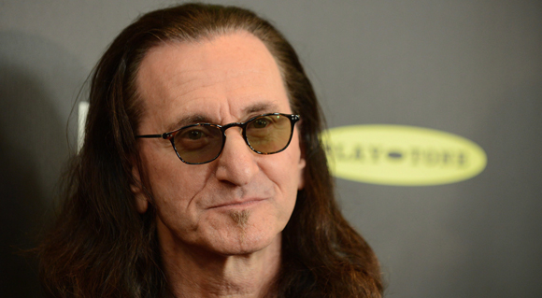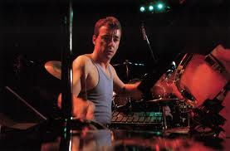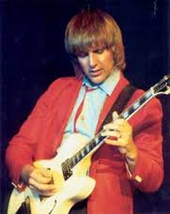

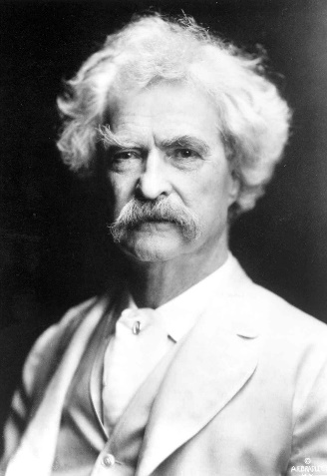

**Clues:**   
Dont chuck that wiki page just yet  
  
**Answer:**

Missile Command

**Reason:**

The first 3 images are the band members of Rush.  
The second image is of Mark Twain, the author of Tom Sawyer.

The song Tom Sawyer by Rush is supposedly the underlying pattern of the Atari game Missile Command.

ptv: the clue could be "to hit the target"

atari means the above in japanese

Question Number : 13

Question Maker :

Difficulty : ***Easy***

Topic : Tech(Recent) / Sports

Question :

**NEXT IS?**

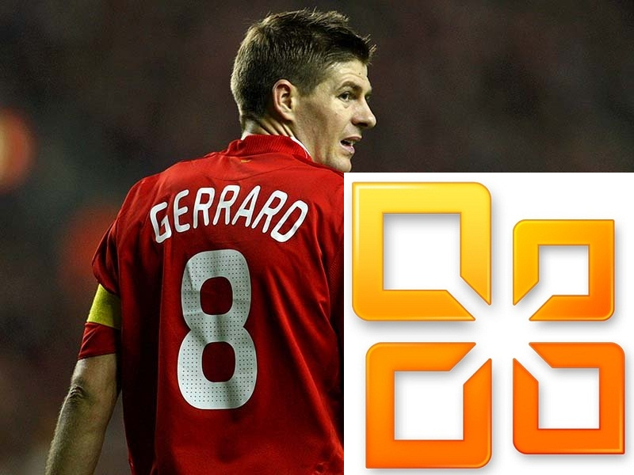

Answer: Coutinho

Reason: The given image consists of Gerrard and MS Office Logo which was a Microsoft product. Windows 8 was the latest operating system for Microsoft. The next one is Windows 10 and not 9. So the answer expected is Liverpool no.10 who is Coutinho.

Question Number: 14

Question Maker: kbhat

Difficulty: ***Easy***

Topic: Tech

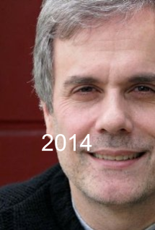

Answer: Reddit

Reason: The left image is Allison Burnett, director of the upcoming 2014 movie Ask Me Anything, which directly links to Reddit. The right is an anagram of ‘Conde Nast’, a mass media company and the owner of Reddit. Scott Dadich (clue) is the Editor - in - Chief of Wired, which is again owned by Conde Nast. Swartz’s project Infogami was merged with Reddit, and is the sole point of connection between Conde Nast and himself.

Clue: Scott Dadich

Question Number : 15

Question Maker: kbhat

Difficulty: ***Easy***

Topic: Gen

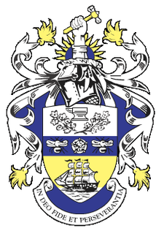

Answer: Brittania

Reason: The right image is that of Arthur, a cat in Code Geass. In this anime, Lelouch vi Brittania is fighting to overthrow the Brittanian empire. All of that is in the wiki (2nd paragraph).

The left image is the crest of the Wadia Group, which controls a number of industries, including the Brittania that we know and love.

Clue: We ain’t no giving you no biscuits

Question Number: 16

Question Maker: kbhat

Difficulty: ***Easy***

Topic: Gaming

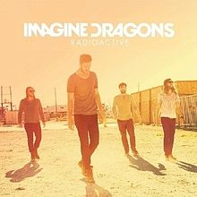

Answer: Half-Life

Reason: Right image: Valve. Valve Software’s first game was Half-Life, and ‘radioactive’ always linked with ‘half life’ in my mind.

Clue: You wrote JEE physics, you say?

Question Number: 17

Question Maker: kbhat

Difficulty: ***Moderate***

Topic: Tech

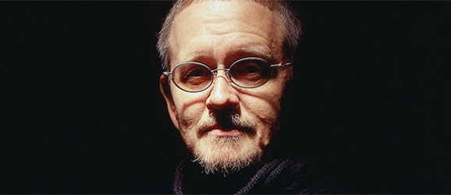

Answer: Zuta

Reason: Zuta is a self-moving printer. Very recent news, actually. The symbol there is the logo of the Jerusalem College of Technology, and Orson Scott Card (pictured) talks about Zuta in his latest essay (on his website). It also turns out that the word ‘zuta’ is Croatian for ‘yellow’.

Clue:  Move aside Roomba; this one’s got ink

Question Number : 18

Question Maker : Chinmay

Difficulty : ***Moderate***

Topic : History / Sci

Question:

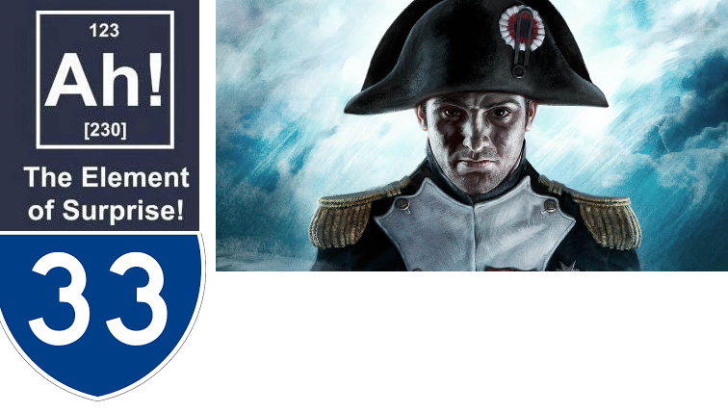

Answer : Scheele’s Green

Reason : Take element no. 33 - Arsenic. The image is of the game Napoleon - Total War. Napoleon and Arsenic give us an article about a conspiracy theory about his death. Apparently it was due to the green coating over his walls called Scheele’s Green.

Clue : Stop looking for elements that aren’t on the periodic table.

(None required. We can keep this as a late question and give a clue if there is too much spam)

Question Number: 19

Question Maker: kbhat

Difficulty: ***Tough***

Topic: Gen

Give us the organisation in charge of the ‘free <insert anagram of answer to pictures here>’ program. We love acronyms. And famous architecture. But mostly acronyms.

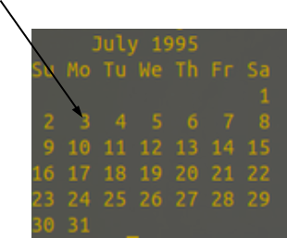

Answer: UNWFP (united nations world food programme)

Reason:  The hex colour code given is that of International Orange, which is the color of the Golden Gate Bridge. It shows up near the bottom of the Google search results page. On July 3, 1995, Eric Atkinson jumped to his death from the bridge. (Fun fact: he was jumper #1000). #firstname => anagram of ‘eric’ is needed = ‘rice’. The Free Rice program ([www.freerice.com](http://www.freerice.com)) is a really fun initiative by the United Nations, and their About page yields the answer.

Clue: None, everything’s in the question.

Question Number : 20

Question Maker : kbhat

Difficulty : ***Easy***

Topic : Gen / Sports

Question: It keeps Asian time. Maybe three pinnipeds will know.

Answer : Tissot

Reason : Official timekeeper for the 17th Asian Games. Very first question / giveaway, perhaps?

Clue : Does Eevee evolve into Incheon?

Question Number: 21

Question Maker: kbhat

Difficulty: ***Easy***

Topic: Tech

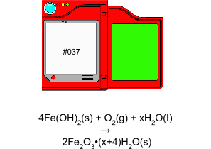

Answer: Mozilla

Reason: First pic -> Rust formation reaction, 2nd pic -> points to pokedex entry 037, which is Vulpix -> connects to Firefox

Rust, Firefox are offerings from Mozilla.

Clue: There must be shumway to get the answer.

Question Number: 22

Question Maker: kbhat

Difficulty: ***Moderate***

Topic:

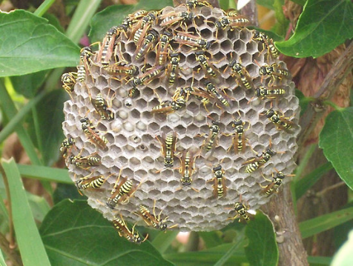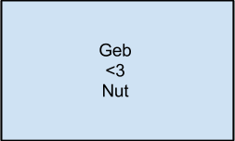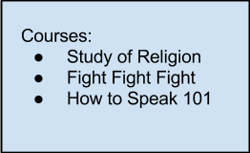

Answer: Simon Elliot

Reason: 1st pic -> hornet’s nest; 2nd -> Geb and Nut are god and goddess from Egytian myths; their daughter is Isis; 3rd -> Courses taken by Al Baghdadi include military training, theology and the art of speech; 4th -> Logo of the Mossad; Baghdadi was revealed (in a recent Snowden document) to be a French Mossad agent by the name of Simon Elliot. Hornet’s nest + Isis is enough to bring up the relevant page.

Clue: Simon says “this one’s easy”.

Question Number : 23

Question Maker : Chinmay

Difficulty : Tough

Topic : Politics/Gen

Question :

інавацыйная решения за пореских проблема



Answer : Paul Ryan

Reason : The blue fist is famous for being a symbol of the State of Wisconsin the USA. The text is encoded in 3 languages. First word is belarusian which means innovative. second word is Russian which means solution. and the last 3 words are serbian for “to taxing problems”. Googling all of them together gives Ryan which is the company tagline. Ryan and Wisconsin together will give Paul Ryan.

Clue : Sometimes, breaking up helps.

Question Number : 24

Question Maker : kbhat

Difficulty : ***Moderate***

Topic:

Question : By the time Hong Kong got Disneyland, we were on the Red Planet.

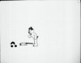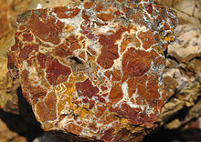

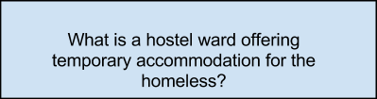

Answer: Tom and Jerry

Reason : 1st -> Jerry the Troublesome Tyke; 2nd -> Mineral called ‘jasper’, was the original screenname for Tom; 3rd -> definition of ‘spike’; Main question -> 2005 was when a Disneyland was established in Hong Kong, and also the year ‘Tom and Jerry Blast Off to Mars’ came out.

Clue : None.

Question Number: 25

Question Maker: kbhat

Difficulty: ***Moderate***

Topic: TV Shows

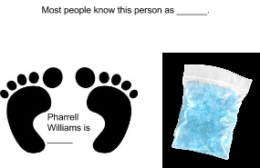

Answer: Gloria

Reason: Pharell Williams is happy. Happy Feet is the takeaway from first pic. Another name for blue meth is ‘smurf dope’ (available on breaking bad wikia). Google smurf and happy feet, you get Sophia Vergara, who most people know as Gloria from Modern Family.

Clue: Little navi.

Question number:26

question maker:ptv

difficulty: ***Easy***

the flux capacitor question

Clue:Dante from devil may cry. (DMC)

Question Number: 27

Question Maker: kbhat

Difficulty: ***Moderate***

Question: Who wins the God’s sickle?

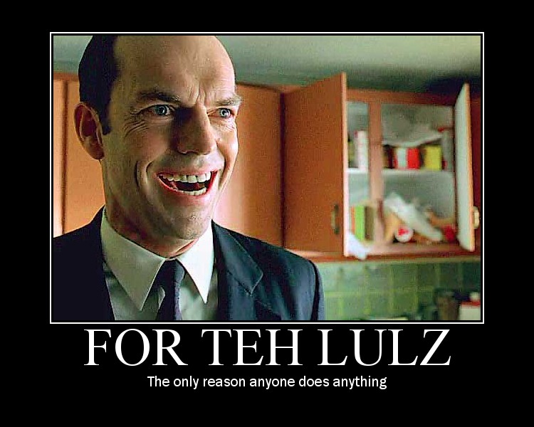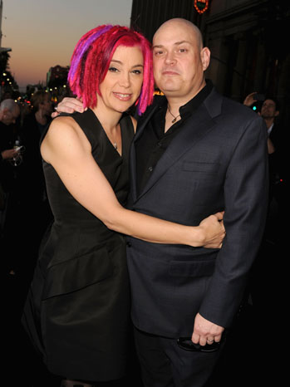

Answer: Natalie Portman

Reason: “We do it for the lulz” is an unofficial catchphrase of Anonymous, the hacker / activist group. Lulzsec often collaborates with Anonymous in such activities. Pictured right are the Wachowski siblings (side note: used to be called W. Brothers, then he (she?) had a sex change!), who directed V for Vendetta (the Guy Fawkes mask is a symbol for both V as well as Anonymous). Natalie Portman received the Saturn Award for Best Actress for her acting in V for Vendetta. [Interestingly, the left pic also has Smith from the Matrix, also directed by the W.S. Distraction, perhaps?]

Clue: The Professional’s favorite girl. ← Give only if absolutely needed, as it’s a giveaway.

Question 28

Question Maker : KSB

Difficulty : ***Moderate***

Question :

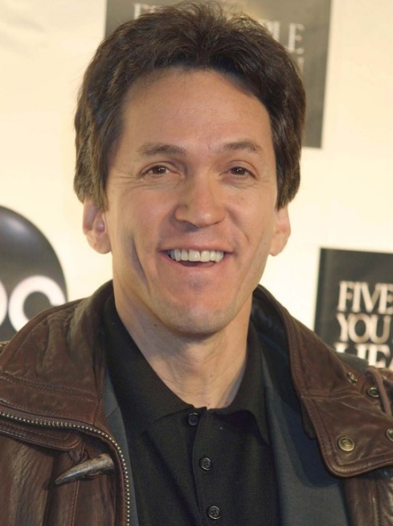

“*Not to be confused with Scoliosis.*“

Answer : Ice Bucket (Challenge)

Reason : The quote is from Wikipedia, which gives this suggestion when you look for “Sclerosis”.

The dude in the photo directed a movie in which the protagonist suffers from Lou Gehrig’s disease.

This leads to ALS, which recently has been in the news cuz of those Ice Bucket Challenges.

Clue : Brr..(?) <- should think of a clue :P

Question Number: 29

Question Maker: kbhat

Difficulty: ***Tough***

A username we seek. Wise men ignore blue/white stripes.

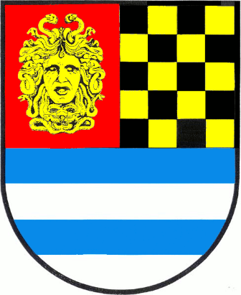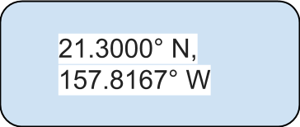

Answer: Darth Musashi

Reason: Ignore the blue / white stripes! We get a picture of Medusa, and what immediately brings to mind a chess board. Clyde Nakamura (a.k.a Darth Musashi in chess circles) was the creator of the Medusa Gambit. The coordinates given are those of Honolulu, Hawaii, where Nakamura lives.

Clue: A Sith lord I am not, young padawan.

Question Number : 30

Question Maker : Chinmay

Difficulty : ***Moderate***

Topic : TV/Code

Question :

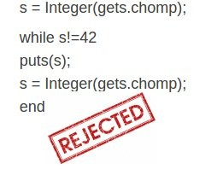

Answer : Doctor Who

Reason : The code is the solution to one of the most famous problems in the competitive  programming arena -> Life, Universe and Everything.

(only for info) It is also a book in the series by Douglas Adams Hittchiker’s Guide to the Galaxy.

It was thought by Adams to be a part of the Doctor Who television series. So the obvious connect is Doctor Who.

Clue : One for the coders.

Question Number : 31

Question Maker : kbhat

Difficulty : ***Easy***

Topic :

Question :

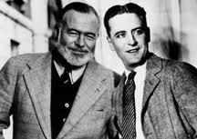

Answer : Stratford-on-Odeon

Reason : The quote is one of James Joyce’s. The two people there are Ernest Hemingway and F. Scott Fitzgerald, two members of a writer’s group called “Shakespeare and Company”, nicknamed by Joyce as Stratford-on-Odéon “ who used it as his office.

Clue: Nicknames are not always easier to remember.

Question Number : 32

Question Maker : Chinmay

Difficulty : ***Tough***

Topic :

Question :



Answer : Google

Reason : The text has to be shifted by 13 i.e rot - 13 and doing that we get “ for a living planet”. This is the motto of the WWF foundation which is associated with it’s mascot, the penguin. The image above that is that of Ubuntu. The Linux penguin to be taken out of it. Penguin and Panda together give us Google, for which Penguin and Panda were the search ranking algorithms.

Clue : 1 long dz eggs?

Question Number: 33

Question Maker: kbhat

Difficulty: ***Moderate***

Topic : Tech / Movie / Geography

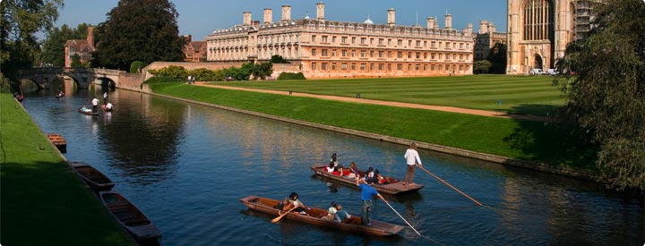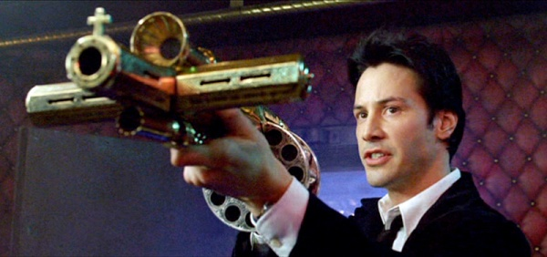

Answer: Fedora

Reason: Constantine is the lower image. Rightmost is the Cambridge Punting Club, we get Cambridge from that. The first image is the trickiest; connection needs to be made with Journey to the Center of the Earth, and from there we get Verne. Verne, Constantine and Cambridge are all releases of Fedora. (Plus, constantine and cambridge alone aren’t enough).

Clue: None.

Question Number: 34

Question Maker: kbhat

Difficulty: ***Easy***

Topic : Music / Game / Lit

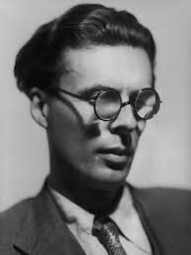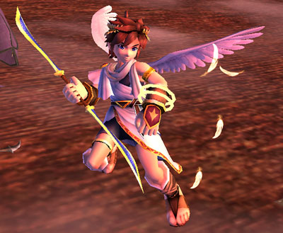

Answer: Iron Maiden

Reason: Left -> Aldous Huxley -> author of Brave New World

Right -> Pit in Super Smash Bros. Brawl -> Protagonist of Kid Icarus

Brave New World and Flight of Icarus are singles by Iron Maiden

Clue: Do re mi ?

Question Number : 35

Question Maker : Chinmay

Difficulty : ***Easy***

Topic : Gen

Question:

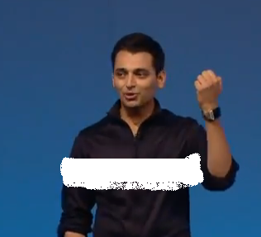

Answer : Nirma

Reason : Pranav Mistry is the alumnus of NIRMA University of Gujrat. And Nirma has this trademark advertisement where they show a shirt gaining its shine through a band of white.

Clue : None required if you can relate to the ad. We can have supplementary clues though.

Question Number : 36

Question Maker : Chinmay

Difficulty :***Tough***

Topic :

Question :

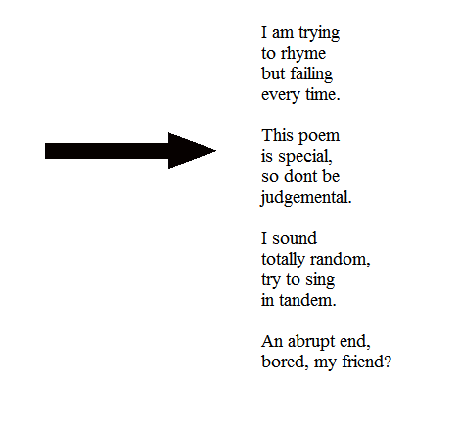

Answer : Parker

Reason :The poem written is utter nonsense, that should point to the fact that there is something else to be taken from it. Notice the number of lines in the “poem” is 14. Such a poem is called a sonnet. Sonnet and Arrow will together give us Parker as they were trademarked products of the pen -  making company. The clue points to the fact that you can also view the arrow as a vector, which was also a Parker product.

Clue : Don’t underestimate the magnitude of this question.

Question Number: 37

Difficulty: ***Tough***

Question Maker: Sriram

Topic: TV Shows

Question:

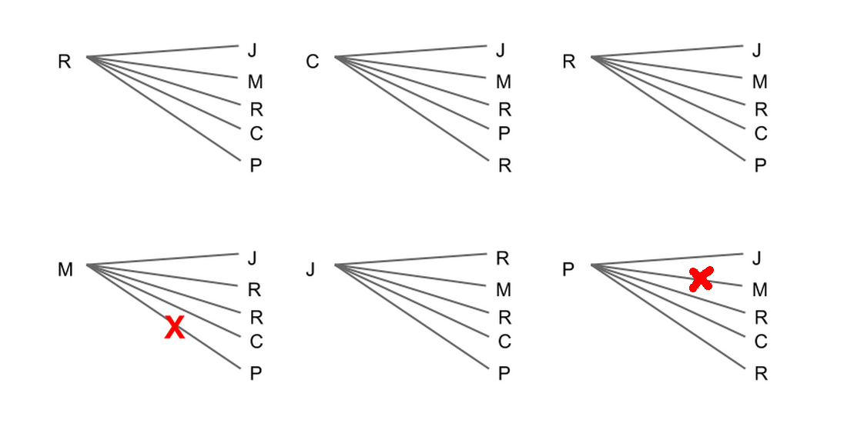

Answer: Rhino Skin

Reason: The image is an exhaustive set of links between all Friends characters. They signify all pairs who’ve kissed. The only pair who haven’t, are Monica and Phoebe.

So, take Monica and Phoebe (Courtney Cox and Lisa Kudrow).

The clue gives ‘Cougars’.

Connect Cougar Town and the above two people, and you get Rhino Skin, the only episode on Cougar Town where both of them appear.

Clue: What connects Paris Hilton, Jennifer Aniston, Mariah Carey and Jennifer Lopez? (If the names aren’t enough I can add more => not an exhaustive list :P )

Question Number : 38

Question Maker : kbhat

Difficulty : ***Moderate***

Topic : Science

Question :

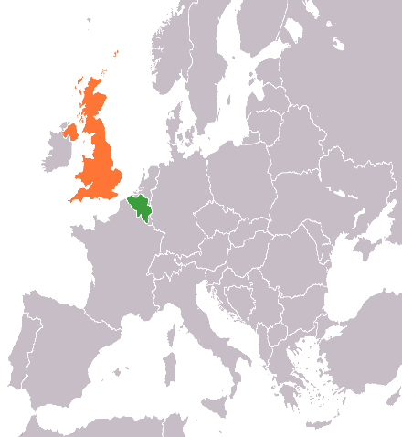φυσική

Answer : Higgs Boson

Reason : 3rd -> Greek for ‘physics’; 2nd -> dynamite, created by Nobel; 1st -> United Kingdom and Belgium, home countries of Peter Higgs and Francois Englert. The two of them shared the 2013 Nobel Prize for Physics for their discovery of the Higgs Boson.

Clue : Spin I do not, shock I do not.

Question Number : 39

Question Maker : kbhat

Difficulty : ***Easy***

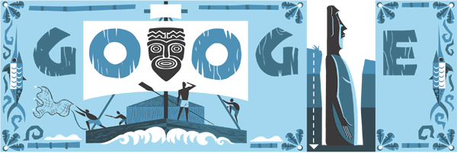

Answer: Tarene

Reason:  1st -> Thor Heyerdahl’s 100th birthday was marked by a Google Doodle recently; this is it. Takeaway: Thor; 2nd -> female port; takeaway: female. Female Thor = Thor Girl a.k.a. Tarene

Clue: None.

Question Number : 40

Question Maker : Chinmay

Difficulty : ***Easy***

Topic : Astro/Gen.

Question :

Poseidon he is to the Greek, a 3 letter word is what I seek.

Answer : Psi

Reason : Poseidon’s Roman counterpart Neptune, symbolised by Psi. “Oppo” is the name of the smart phone company which has recently manufactured phones for taking better selfies. But the clue mentions Oppa, a link to the famous “Gangnam Style” by Psy.

Clue : Oppa SmartPhone, taking selfies is much more easier now!

Question Number : 41

Question Maker : kbhat

Difficulty : ***Easy***

Topic : Food

Question :



Answer : Baklava

Reason : 1st -> Ottoman; 2nd -> Filo pastry, take “filo”; Baklava is a characteristic cuisine of the Ottoman Empire, made of layers of filo combined with other ingredients.

Clue : Sounds like ski mask, it does.

Question Number: 42

Question Maker: kbhat

Difficulty: ***Opening question***

Topic: TV

Question:

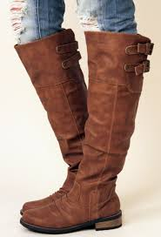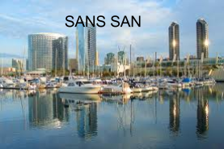

Answer: Dora the Explorer

Reason: 1st -> Boots; 2nd -> San Diego; Boots + Diego = Dora the Explorer

Clue: sans san.

Question Number: 43

Question Maker: kbhat

Difficulty: ***Moderate***

Topic: Music

Question:

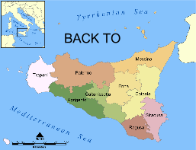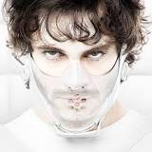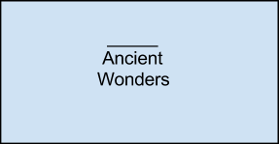

Answer: Hoodlums

Reason : 1st -> Map of Sicily, takeaway “Back to Sicily”; 2nd -> Hannibal from, well, Hannibal; 3rd -> Seven; Hannibal the Great is the name of an artist flying under the banner of Hanz On Music; he released a mix tape called Back to Sicily. Hoodlums is the 7th track in that tape. [Not too hard, since hannibal back to sicily brings up a link with the track list].

Clue: ???

Question: 44

Question Maker: Kartik Sreenivasan

Difficulty: ***Easy***

Topic: Entertainment

DJ Nash  + J Jonah Jameson

Answer: Growing up fisher

Clue: Some people can pass the BAR exam with their eyes closed.

Explanation: The series is based on the childhood of DJ Nash( not a dj :P) and the protagonist is J.K Simmons who played Jameson in the spiderman trilogy

Clue - The protagonist is a blind lawyer :P

Question: 45

Question Maker: Kartik Sreenivasan

Difficulty: ***Moderate***

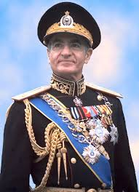 + 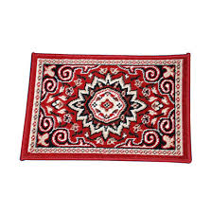

Clue: Le roi est mort, vive le roi!

Answer: Check Mate

Explanation: The first is a picture of Muhammad Raza Shah, and the second is bleh. The 3rd picture is a mat. The word check mate comes from the Persian words: “shah mat” which literally means the king is dead. Clue is french for “The king is dead, long live the king!”

Question Number: 46

Question Maker: Kartik Sreenivasan

Topic: Racing/ F1

Difficulty:***Easy***

Question: They have powered the finest through many a chequered flag. They were the masters of the Turbo era. They are back. They lost to the Germans in Pearl Harbor, they do not want to lose again.

Answer: Honda

Reason: Honda is coming back to formula 1 in 2015. Most of the question is just to mislead :P The germans joke is to indicate that they are japanese. The clue is the omnipresent activa.

Clue: Chances are you have one in your house. Either as a generator or your daily commute.

Question Number: 47

Question Maker: kbhat

Difficulty: ***Easy***

Topic: Movie / Games

Question:

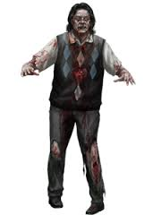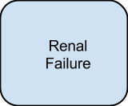

Answer: Valifin

Reason: Zombie and umbrella point to the Umbrella Corporation, the villain in all Resident Evil productions. From their wikia, Valifin is an experimental pediatric heart

medication and has renal failure as a possible side effect.

Clue: None.

Question Number: 48

Question Maker: Chinmay

Difficulty: ***Moderate***

Topic: Food

Question: You’ve got 30 minutes or the second one’s free.

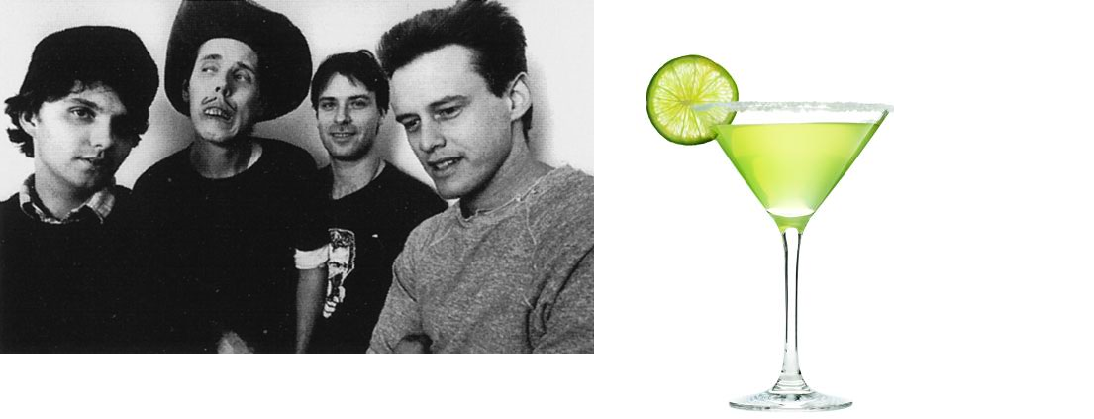

Answer: Fior di latte

Reason: The left image is a picture of the band Cows. And the right is a pic of Margarita. The clue is the tagline of Dominos Pizza to point to Pizza . Margarita and Pizza should give them Mozarella Cheese which is made using buffallo milk. It is called Fior di Latte when made from Cow Milk.

Clue:

Question Number : 49

Question Maker : Chinmay

Difficulty : ***Tough***

Topic : Nature

Question : “the first of the name”

(have a soundcloud / dropbox clip to download a small clip of the cicada buzzing sound.) and have an arrow pointing at itself indicating a cycle. something like -

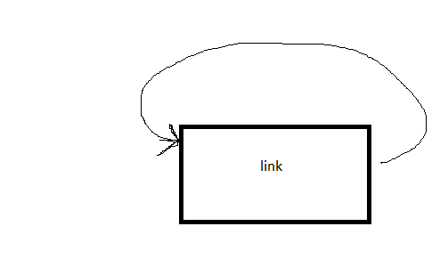

---> here is the link we can embed

https://drive.google.com/file/d/0B7vJXtT2KLpWVnl2eWR4VC0xcFk/view?usp=sharing

Answer : 2

Reason: Cicada life cycles are famous for being in prime number domain. We have a arrow pointing at itself to denote a cycle. The first prime number is 2.

Clue: none . depends on the spam

Question Number: 50

Question Maker: kbhat

Difficulty: ***Easy***

Topic: Mythology

Question:

Cry, foe!  Run amok!  Fa awry!  My wand won’t tolerate this nonsense.

Quid est nomen deae?

Answer: Diana

Reason: A day ago, J.K. Rowling tweeted the above anagram, and eager fans attacked it. Turns out it stands for ‘Newt Scamander only meant to stay in New York for a few hours’. On Googling Newt Scamander, we get his full name, and the second name is Artemis. The second part is a question in Latin: ‘What is the name of the goddess?’. The Roman form of Artemis is Diana.

Clue: Moon lady, mind your language.

Question Number : 51

Question Maker : KSB

Difficulty : Easy-Moderate (***Moderate*** only - Chinmay :p)

Topic : TV Shows

Question :

Ross and Chandler bought a ‘special’ computer in Kansas.

Answer : Courage the cowardly dog

higgs

Reason :

Ross’ middle name is Eustace. Chandler’s middle name is Muriel. The town ‘Nowhere’ is in Kansas, and the special computer talks. All this is the set of the 2000’s cartoon show, Courage the Cowardly Dog.

Clue : Also, Marvin Eriksen.

Question Number: 52

Question Maker: Kartik Sreenivasan

Difficulty:***Moderate***

Question: Connect

Dear diary:

Morning:

Today is the  brightest day I’ve seen in a long time.

I caught several criminals.

Started writing a book.

Night:

The night was reaaally dark.

I saved the universe.

Answer: Nathan Fillion

Explanation: Nathan fillion plays the lead role in the TV show Castle (opening screen) and also is the voice actor for Hal Jordan in the animated movies of Green Lantern.

Clue: Use your will power.

Question: 53

Question Maker: Kartik Sreenivasan

Difficulty: ***Moderate***

Question: Drink Coffee else you may end up getting X. But then again Y has X but still managed to land the lead role in a movie which the Karate Kid turned down. Id X.

Answer:

Michael J Fox

Clue:

The Karate kid probably didn’t like being called Calvin Klein by his mom.

Question Number : 54

Question Maker: Chinmay

Difficulty: Easy

Topic : Sports

Question :

In a game of cricket between team A and B, team A need 5 runs of a single ball. They manage to win even though team B concedes no boundaries. Where has the ball hit?

Answer : Wicketkeeper’s helmet

Reason : In cricket, if the ball hits the wicketkeeper’s helmet, the batting team is awarded runs as extras. Though the ball is counted, the team gets additional 5 runs.

Clue: None

Question Number : 55

Question Maker : KSB and Sriram

Difficulty : ***Moderate***

Question :

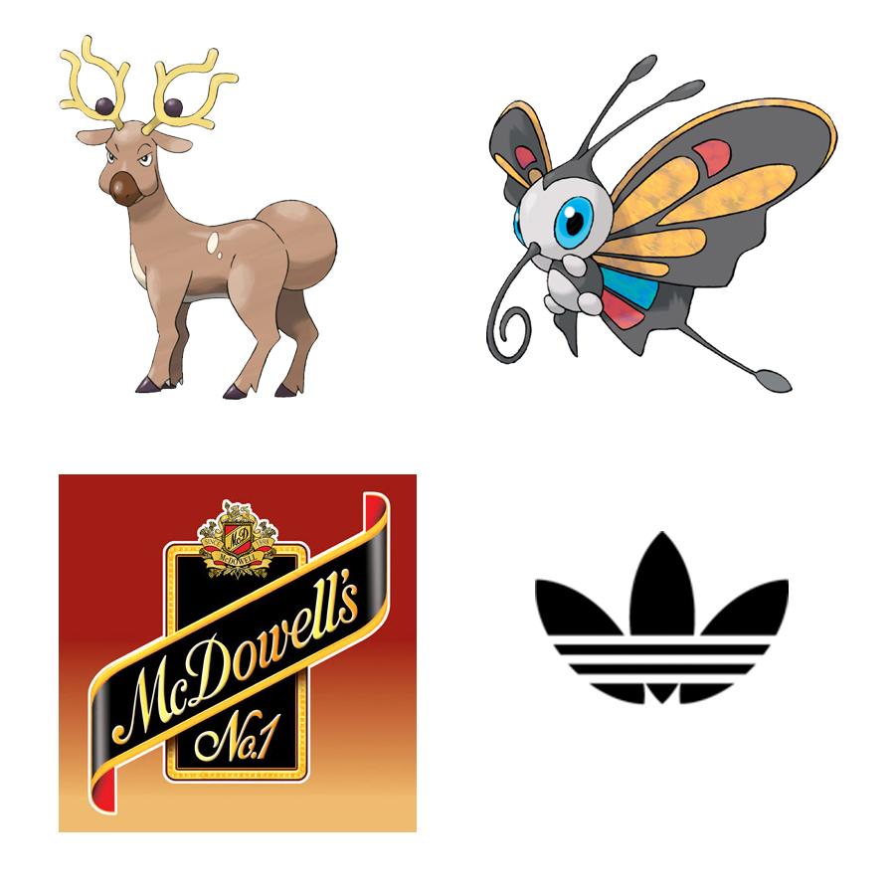

Answer : MA Long

Reason : Stantler is a Stag pokemon. Similarly, Beautifly is a butterfly pokemon. The 4th image is Adidas. Stag, Butterfly and Adidas are big Table Tennis equipment manufacturing companies.

The mcdowell’s thing is only for the ‘No 1’. So we want the 1st ranked dude in TT.

That is this MA Long guy :P

Clue : Dimelo

That’s Enrique’s spanish version of ‘Do You Know’ which is also known as the ‘ping pong song’.

Question number : 56

Question Maker : KSB

Difficulty : ***Hard***

Question :

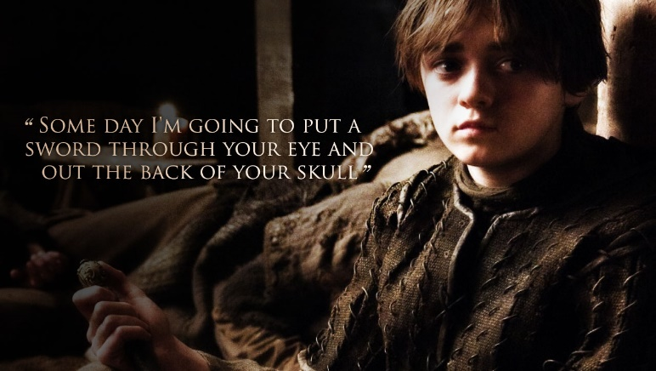

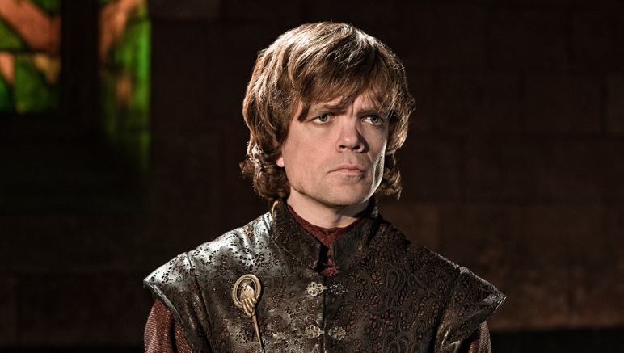

Think Treecko, Torchic and Mudkip. Oh, also Salamence.

Answer : Inheritance

Reason : The person in the first image is Arya Stark . The second guy id Tyrion Lannister but we are supposed to take dwarf from it. Treeko Torchic and Mudkip are starters in Pokemon Ruby/Sapphire and Emerald. We have to take Sapphire. (Maybe we can highlight the text in that color to specify which one to consider). Salamence is Dragon Type. Dragon, Arya, Sapphire and Dwarf we get Inheritance.

Clues : Highlighting the starters in blue color should be enough.

An analyst rank

ranger, a gray heart,

leaves an ignorant kit

famed by a grey tit!!!

What is the awesome revelation here????